PHASE 6 – PROJECT TESTING
1. Introduction
The Project Testing phase focuses on verifying the functionality, reliability, and output of the LegalEase: AI-Powered Legal Document Generator.
Testing is performed after the major development activities are completed. The objective is to ensure that the frontend, FastAPI backend, Gemini AI integration, document generation, editing, formatting, and download functionalities work as expected.The testing process verifies the complete workflow from user input to final document generation.
2. Testing Objectives
The main objectives of testing LegalEase are:
* To verify that all required input fields accept valid information.
* To verify communication between the Streamlit frontend and FastAPI backend.
* To verify the `/generate` API functionality.
* To verify Gemini-based legal document generation.
* To verify document preview functionality.
* To verify document editing functionality.
* To verify TXT, DOCX, and PDF generation.
* To verify document formatting.
* To identify errors during document generation and export.
* To verify the complete end-to-end application workflow.
3. Testing Approach
LegalEase is tested by providing different combinations of document information and checking the generated results.
The testing process includes:
1. Entering user inputs.
2. Sending the generation request.
3. Processing the request through FastAPI.
4. Generating content using Gemini.
5. Displaying the generated document.
6. Editing the generated content.
7. Exporting the document.
8. Opening and verifying the exported files.
The main document scenarios used for testing are:
* Employment Contract
* Non-Disclosure Agreement
* Lease Agreement
4. Functional Testing
Functional testing verifies whether each major feature performs its intended operation.
4.1 Input Field Testing
The following input fields are tested:
* Document Type
* Parties Involved
* Terms & Conditions
* Effective Date
Valid information is entered into each field and the system response is observed.
Expected Result:
The system should accept the provided information and allow the user to generate the document.
Actual Result:
The application processes the entered information and proceeds with document generation.
5. Legal Document Generation Testing
The AI document generation functionality is tested using different document types.
Test Case 1 – Employment Contract
Input: Employment-related document details including parties, responsibilities, compensation, and confidentiality terms.

Expected Result:
The system should generate an employment contract based on the provided information.
Actual Result:
The generated legal document is displayed in the application preview.
Status: Pass
Test Case 2 – Non-Disclosure Agreement
Input: Parties, scope of confidential information, and effective date.
Expected Result:
The system should generate an NDA using the provided information.
Actual Result:
The system generates and displays the NDA content.
Status: Pass
Test Case 3 – Lease Agreement
Input: Property address, tenant details, and lease terms.
Expected Result:
The system should generate a lease agreement based on the provided information.
Actual Result:
The generated lease agreement is displayed for review.
Status: Pass
6. API Testing
The FastAPI backend is tested to verify the document generation endpoint.
The primary endpoint is:
“text
POST /generate”
The request contains document information such as:
* `document_type`
* `parties`
* `terms`
* `dates`
The backend validates the request and passes the information to the Gemini document generator.
Expected Result:
The API should accept a valid request and return generated legal document content.
Actual Result:
The FastAPI endpoint processes the request and returns the generated document content to the frontend.
Status: Pass
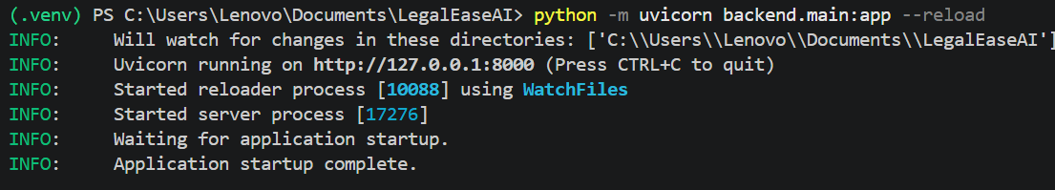
7. AI Integration Testing
The Gemini AI integration is tested by providing different legal document requirements. The testing verifies whether the generated content changes according to the document type, parties, terms, and effective date supplied by the user.
Expected Result:
The AI should generate content relevant to the supplied document requirements.
Actual Result:
The generated document is displayed based on the provided inputs.
Status: Pass
8. Document Preview Testing
The document preview functionality is tested after successful AI generation.
The generated content is displayed using the application's formatted preview interface.
Expected Result:
The user should be able to view the generated document before downloading it.
Actual Result:
The generated document is displayed in the preview area.
Status: Pass
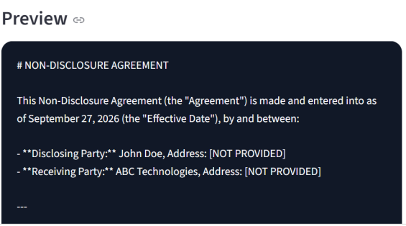
9. Document Editing Testing
The editing functionality is tested by modifying the generated document content.
The user can select the edit option and modify the generated text before downloading the final document.
Expected Result:
The user should be able to modify the generated content.
Actual Result:
The generated document can be edited before export.
Status: Pass
10. TXT Export Testing
The TXT download option is tested to verify plain-text document generation.
Expected Result:
The system should generate and download the document in `.txt` format.
Actual Result:
The generated legal content is exported as a TXT file.
Status: Pass
11. DOCX Export Testing
The DOCX export functionality is tested using the generated legal document.
The generated Word document is checked for:
* Document title
* Paragraph formatting
* Logo
* Terms table
* Footer
* Overall document structure
Expected Result:
A properly formatted DOCX document should be generated.
Actual Result:
The system generates the DOCX document using the document formatting functionality.
12. PDF Export Testing
The PDF export functionality is tested using the generated legal document.
The PDF is checked for:
* Logo
* Document content
* Section headings
* Terms
* Footer
* Overall formatting
Expected Result:
A properly formatted PDF document should be generated.
Actual Result:
The system generates the PDF document with the implemented formatting.
Status: Pass
13. End-to-End Testing
The complete LegalEase workflow is tested from input to final document download.
The end-to-end process is:
Enter Document Details
↓
Click Generate Document
↓
FastAPI Request
↓
Gemini AI Processing
↓
Generated Legal Document
↓
Preview
↓
Edit Document
↓
Select Export Format
↓
Download Final Document
Each stage is verified to ensure that the components work together correctly.
Expected Result:
The complete workflow should execute successfully without interrupting the document generation process.
Actual Result:
The application completes the document generation and export workflow.
Status: Pass
14. Error and Input Validation Testing
The application should also be checked with incomplete or invalid input conditions.
Examples include:
* Missing document type
* Missing parties
* Missing terms
* Missing effective date
* Incomplete document information
The purpose of this testing is to verify that the application does not proceed with incomplete information where validation is required.
Note: The exact error message or behavior should be documented only if it was actually implemented and tested in the application.
15. Testing Result
The testing activities verify the major functionalities of the LegalEase application.
The tested components include:
* User input
* FastAPI backend
* Gemini AI integration
* Legal document generation
* Document preview
* Document editing
* TXT export
* DOCX export
* PDF export
* Document formatting
* End-to-end workflow
The testing results provide evidence that the implemented application functions according to the developed workflow.
16. Testing Evidence
The following screenshots can be included as testing evidence:
1. Employment Contract generation
2. NDA generation
3. Lease Agreement generation
4. Document preview
5. Document editing
6. DOCX output
7. PDF output
8. Complete final workflow
It is not necessary to include screenshots for every individual test case if the same result is already clearly demonstrated by another screenshot.
17. Conclusion
The Project Testing phase verifies the major functionalities of the LegalEase: AI-Powered Legal Document Generator. The application is tested for input processing, API communication, Gemini-based document generation, document preview, editing, and export functionality. The testing process confirms the complete workflow from entering legal requirements to generating and downloading the final document. The testing results provide the necessary evidence for proceeding to the documentation and final project demonstration phases.

